The launch of Workday HCM for Specialty Companies is almost upon us. It’s time to get your associates into the habit of using Workday to stay connected with the company.

This box includes the materials you will need to promote Workday:

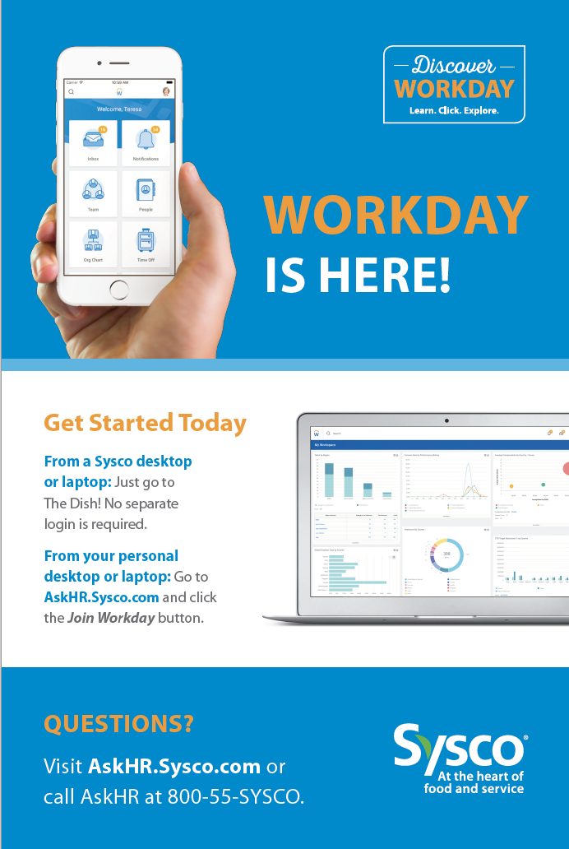 | Static Clingz Posters – Starting January 27, post the clingz in areas with high visibility to drive traffic to the pop-up banners.
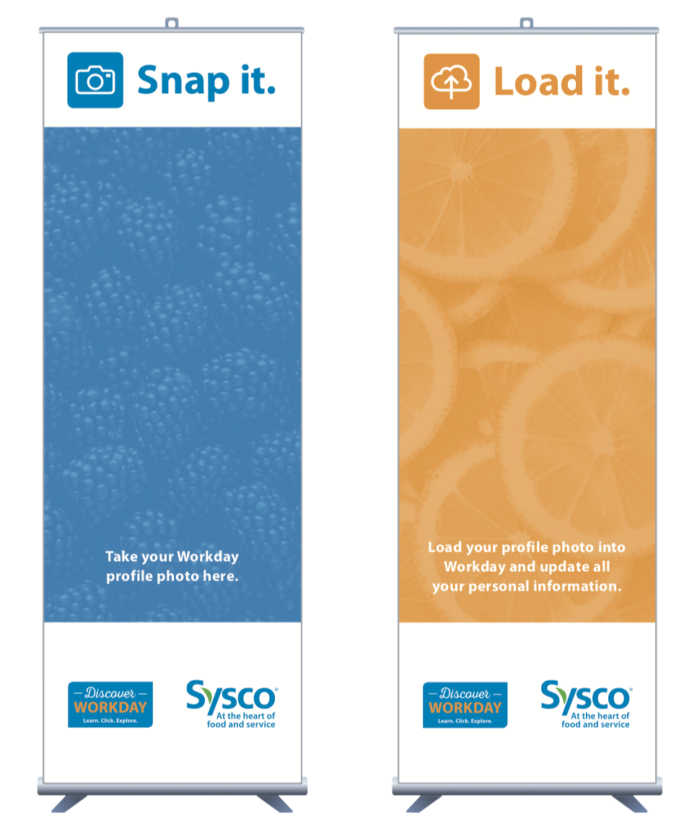 | Pop-up banners – Give associates a solid background for pictures for their profile set up. Beginning January 27, place these in highly visible locations that have space for associates to congregate, such as break rooms and common areas.
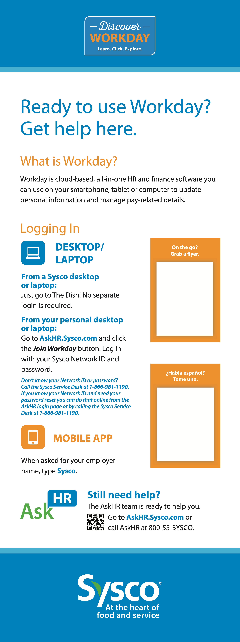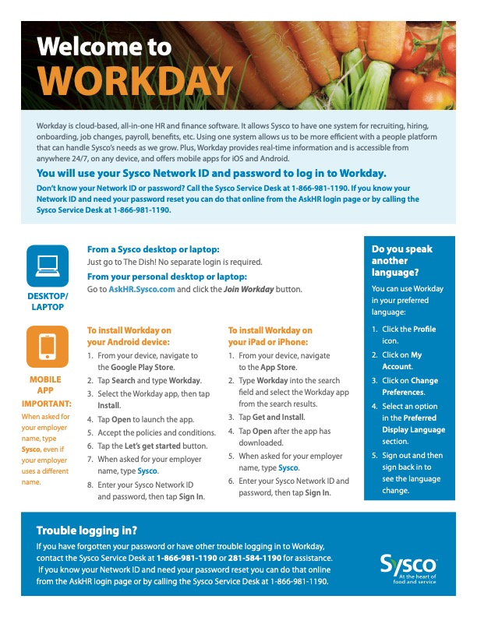 | Free-Standing Display – Beginning January 27, place this display in your training room or near a self-service kiosk. The display has two areas where you can attach the English and Spanish Logging In tear pads using Velcro.  - Logging In Tear Pads (English and Spanish) – A large amount of tear pads are included in the box. These are a key way to help associates log in. Attach the tear pads to the Free-Standing Display using the Velcro included and distribute them in meetings, put them next to kiosks, hand them out in new hire orientation, etc.  - Velcro – Use the Velcro to attach the Logging In Tear Pads to the Free-Standing Display. There are designated spaces for the English and Spanish tear pads.
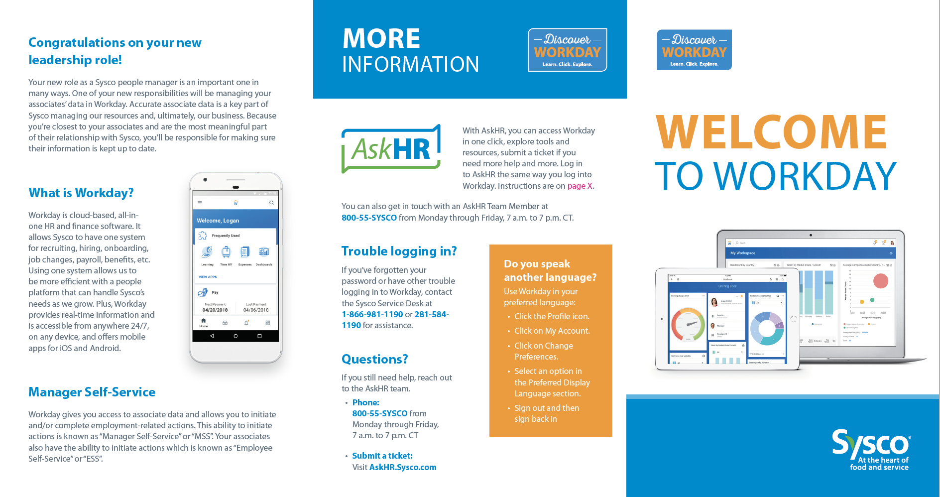  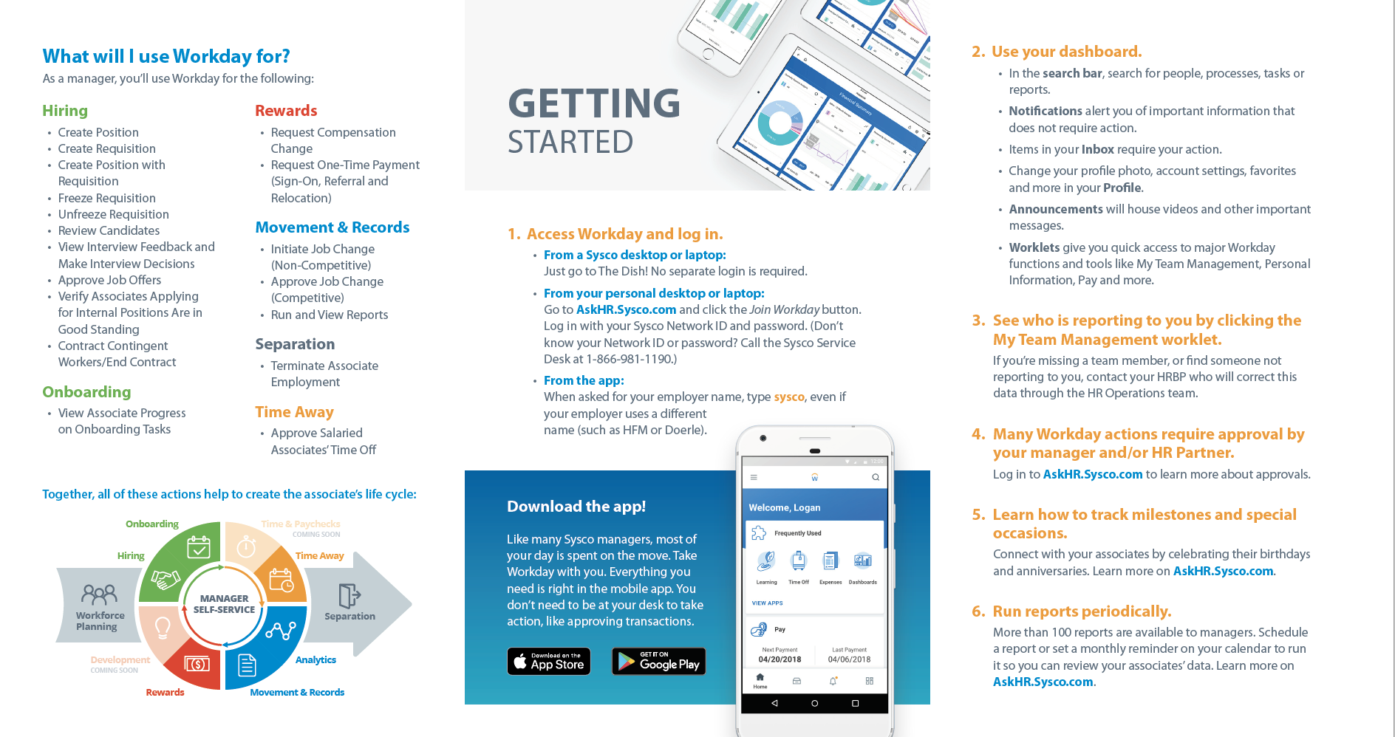 | Manager Brochure – Gives managers an overview of Workday, how to get started and where to find more information. Distribute to managers on January 27. Extra brochures are included to distribute when you hire new people managers throughout 2020.

Questions? Email AskHROps@sysco.com.

Thank you!

